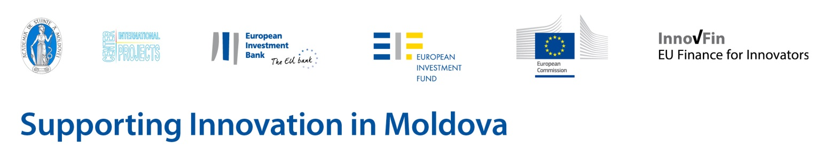
Corporate seminar on the EIB Group’s financial instruments for innovative businesses

Wednesday 13 July 2016, 14:00 – 18:30
Radisson Blu Leogrand Hotel, Mitropolit Varlaam str. 77, P.O. Box MD 2012, Chisinau, Moldova

To register please complete this form and return to innovfinevents@eib.org by Wednesday 6th July 2016. We will be registering individuals on a first-come, first-served basis and seminar participation is free of charge. Delegates are responsible for covering their own travel costs.

Title (Mr/Mrs/Miss):
Surname: First name:
Organisation:
Position:
Tel: Email:
Date:

INFO-DESK REGISTRATION
We can also offer bilateral meetings in the afternoon between 12:30 and 13:30. If you are interested please complete the section below and we will endeavour to schedule a specific time slot with one of our experts.
Yes, I would like an addition bilateral meeting.

- BANKS AND FINANCIAL INTERMEDIARIES

I am a bank/financial intermediary who would like to know more about the EIB Group product offering.

- COMPANIES
I am an innovative small-sized company who is interested in debt financing from EUR 25,000 to EUR 7.5m and in connecting with potential financial intermediaries for products delivered by them.
I am an innovative or fast growing company* who is interested in debt financing (long term senior, subordinated or mezzanine loans) from EUR 7.5m to 25m.
I am a company carrying out R&D activities who is interested in debt financing (loans and guarantees) from EUR 25m to 300m.

- OTHER
I am looking to speak with an EIB Group staff representative on the following topic:

*Definition of an innovative or fast growing company:
(a) An eligible MGF or MCG Final Recipient should intend to use the MGF Operation or MCG Transaction to invest in producing or developing products, processes and/or services that are innovative and where the business plan evidences a risk of technological or industrial failure, or a business risk; or
(b) is a “fast-growing enterprise”, measured as follows:
- an enterprise with average annualised growth in turnover of at least 10% over a three-year period; or
- an enterprise with average annualised growth in (Full-Time Equivalent (FTE)) employees of at least 5% over a three-year period and with one hundred (100) or more employees at the beginning of the observation period; or
(c) is an enterprise that has a significant innovation potential or is an “R&I-driven enterprise”, satisfying at least one of the following criteria:
1) its certified accountant(s) have highlighted R&I expenses/investment in the latest financial statements in an amount at least equal to 5% of its annual turnover;
2) it undertakes to spend an amount at least equal to 80% of the MGF Operation or MCG Transaction amount in R&I expenses/investment in the next 36 months as indicated in its business plan;
3) it has been formally awarded grants, loans or guarantees from European R&I support schemes (e.g. Horizon 2020 or FP7) or through their funding instruments (e.g. Joint Technology Initiatives, "Eurostars") or through a national or regional research or innovation support schemes over the last 36 months;
4) it has been awarded an innovation prize over the last 24 months;
5) it has registered at least one patent in the last 24 months;
6) it has received an investment from a private-equity fund or from a business angel being a member of a business angel network; or such a private equity fund or business angel is a shareholder of the MGF or MCG Final Recipient at the time of its application for the MGF Operation or MCG Transaction;
7) it has its registered seat in a science, technology or innovation park or technology cluster or technology incubator, in each case with activities relating to R&I; or
8) it has benefited from tax credit or tax exemption related to investment in R&I in the last 24 months.

Protection of Personal Data: http://ec.europa.eu/justice/data-protection/index_en.htm

